CIS 3252 — Project 5
1. Summary
This paper explains how I built a complete data pipeline which was basically a step-by-step process that took raw data and turned it into charts a client would actually be able to use. To do this, I used four different tools: Antigravity, Microsoft Excel, MySQL, and Tableau. Each tool had a specific job, and they all worked together in order to get good visuals and charts the client can utilize.
The data I worked with was a fake set of 90,000 cryptocurrency trades. The client wanted to know if their trading software was working correctly, specifically, if it was fast enough, consistent enough, and making the right profit on every trade. So the job was to prove it with charts.

2. The Five Steps of the Pipeline
The way I like to think of the pipeline is basically like an assembly line. The data goes in at one end, gets cleaned and organized at each station, and comes out the other end as professional charts and visuals.

Step 1 — I Used AI to Understand the Data (Antigravity)
Before touching the data, I asked Antigravity to read through the dataset and explain it. I gave the AI two separate prompts. The first prompt I asked it was to basically create a data dictionary, which is basically a document that explains what every column in the spreadsheet that contains the data means. The second prompt I asked the AI was to design a dashboard that is a reflection of the data set.
The AI also checked whether the data was reliable enough to draw conclusions from. It found that the data was clean and every single trade made exactly 1% profit with almost zero variation. The AI confirmed the data was good enough to use as a testing environment.

Step 2 — I used AI to Build a Quick Website to Preview the Data (Python)
Once I knew the data was good, Antigravity was able to use Python to create a website for it. Antigravity helped me write a program that built a simple website where I was able to see the data as charts in a browser. This was basically a rough draft of the final dashboard.
This step was important because it let me catch any problems early. I asked Antigravity to check things like how long each trade took, which coins were traded the most, and whether the system slowed down at certain times of day. Everything looked clean, so I knew it was safe to move the data into a real database.

Step 3 — I Cleaned and Organized the Data in Excel (Power Query)
Next, I brought the raw data file into Microsoft Excel to clean it up before putting it in the database. Within Excel I used Power Query which lets you transform data without changing the original file. I used it to fix the date columns which were converted into normal readable dates and times.
I also created a brand new column called time_diff that calculated how long each trade took from start to finish. This was one of the most important numbers the client wanted to see. After creating this column, I also made some basic charts in Excel. Finally it was time for the data to be transferred to MySQL

Step 4 — I Put Everything Into a Real Database (MySQL)
After Excel confirmed the data was clean, I loaded all 90,000 rows into MySQL with help from Antigravity. I used a Python script which was created by Antigravity to transfer the data automatically. The script moved the data into MySQL seamlessly.
Once the data was in MySQL, I created five Views, one for each chart the client needed. By doing all the math inside MySQL, I made sure that Tableau would not have to do any heavy lifting and it would just be able to use MySQL’s pre-calculated results and display them.

Step 5 — I Made the Final Charts in Tableau
The last step was connecting Tableau to the MySQL database and turning the data into professional-looking charts. Tableau is designed for making visuals, so this part was pretty easy for the most part and the only difficult decisions were choosing the right chart type to make everything look clean and easy to read.
For each of the five client goals, I picked a specific chart type that best showed what the data was saying. Tableau pulled the pre-calculated numbers directly from my MySQL Views, so the charts loaded fast. The final result was a set of five charts that directly answered each of the client's questions.

3. What the Charts Show
Chart 1 — Is the System Slow at Certain Times? (Histogram)
This chart shows how long trades took to finish. The horizontal axis shows different time ranges and the vertical axis shows how many trades fell into each range.
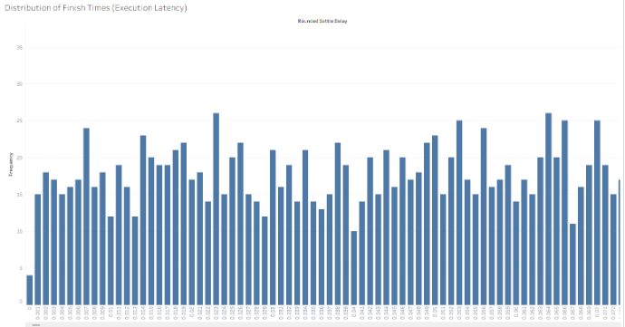
The bars all came out at around the same height, which means trades were spread evenly across all time ranges. This means that the system never got stuck or slowed down at a particular time which proves that the system has no slowdowns.

Chart 2 — Which Coins Were Traded the Most? (Horizontal Bar Chart)
This chart ranks the top 10 cryptocurrency coins by how many times they were traded. The coin names are listed on the left side and the bars extend to the right where longer bars meant more trades. 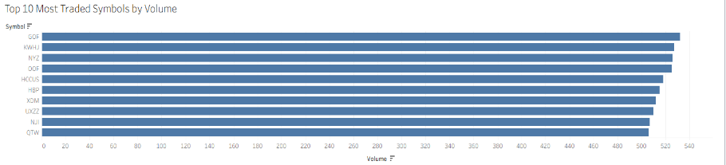

The chart shows which coins were traded the most. These are the most important coins for the client to focus on, since there is more data on them and the software has more experience handling them.
Chart 3 — Did the System Get Slower Over Time? (Line Chart)
This chart tracks the average trade finishing time across the entire testing period. The horizontal axis is time and the vertical axis is how many seconds trades took on average.
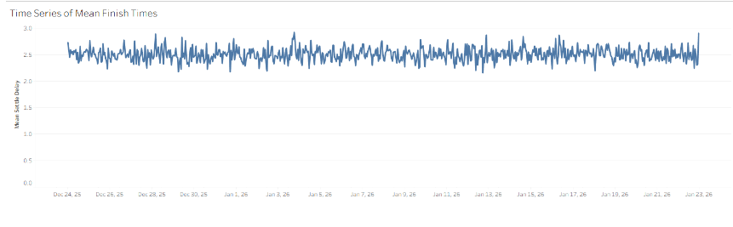
The line didn’t deviate from the average throughout the whole period it didn’t trend upward over time. This is important because it means the system did not get slower as more trades happened.
Chart 4 — What Is the Fastest the System Can Go? (Bubble Chart)
This chart focuses on the fastest trades in the entire dataset. Each bubble represents a different coin, and the size of the bubble shows how fast its fastest trades were. Smaller bubble means faster.
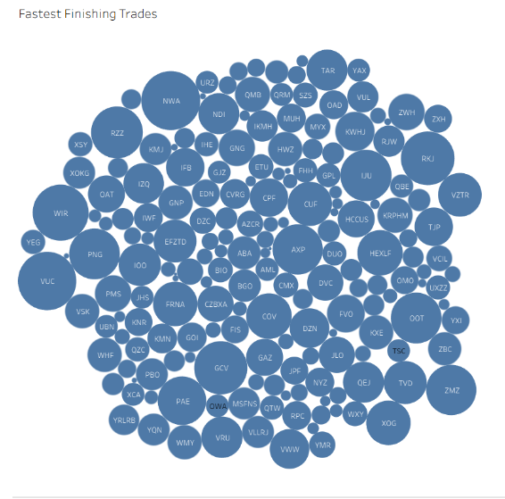

Some coins like NFC and OOT consistently showed up in the fastest group. This tells the client which coins run the most efficiently and could handle more volume if needed.

Chart 5 — Did the Same Amount of Trades Happen Every Day? (Daily Histogram)
This chart shows how many trades happened each day across the testing period. Each bar represents one day.
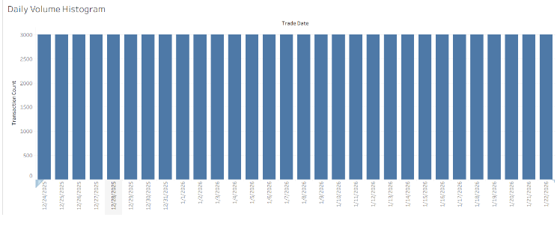
All the bars are exactly the same height, which means the same number of trades happened every single day. This is actually really important because it proves the test was run fairly. If some days had way more trades than others, it could mess up the other results.

5. Final Conclusions
The five-step pipeline which utilized Antigravity, Excel, MySQL, and Tableau took a massive amount of raw data (90,000) and turned it into five clear charts that answered every question the client had. Each tool had a specific job, and by putting them in the right order, I was able to build something that is both accurate and easy to understand.
Here are the three most important results:
- 90,000 Trades Analyzed: The system handled all of them without any errors or failures.
- Average Trade Time of 2.50 Seconds: This was consistent across all coins and all days. No slowdowns.
- Exactly 1.0% Profit on Every Trade: Regardless of which coin was being traded.

